Megan A. Zmick, Associate
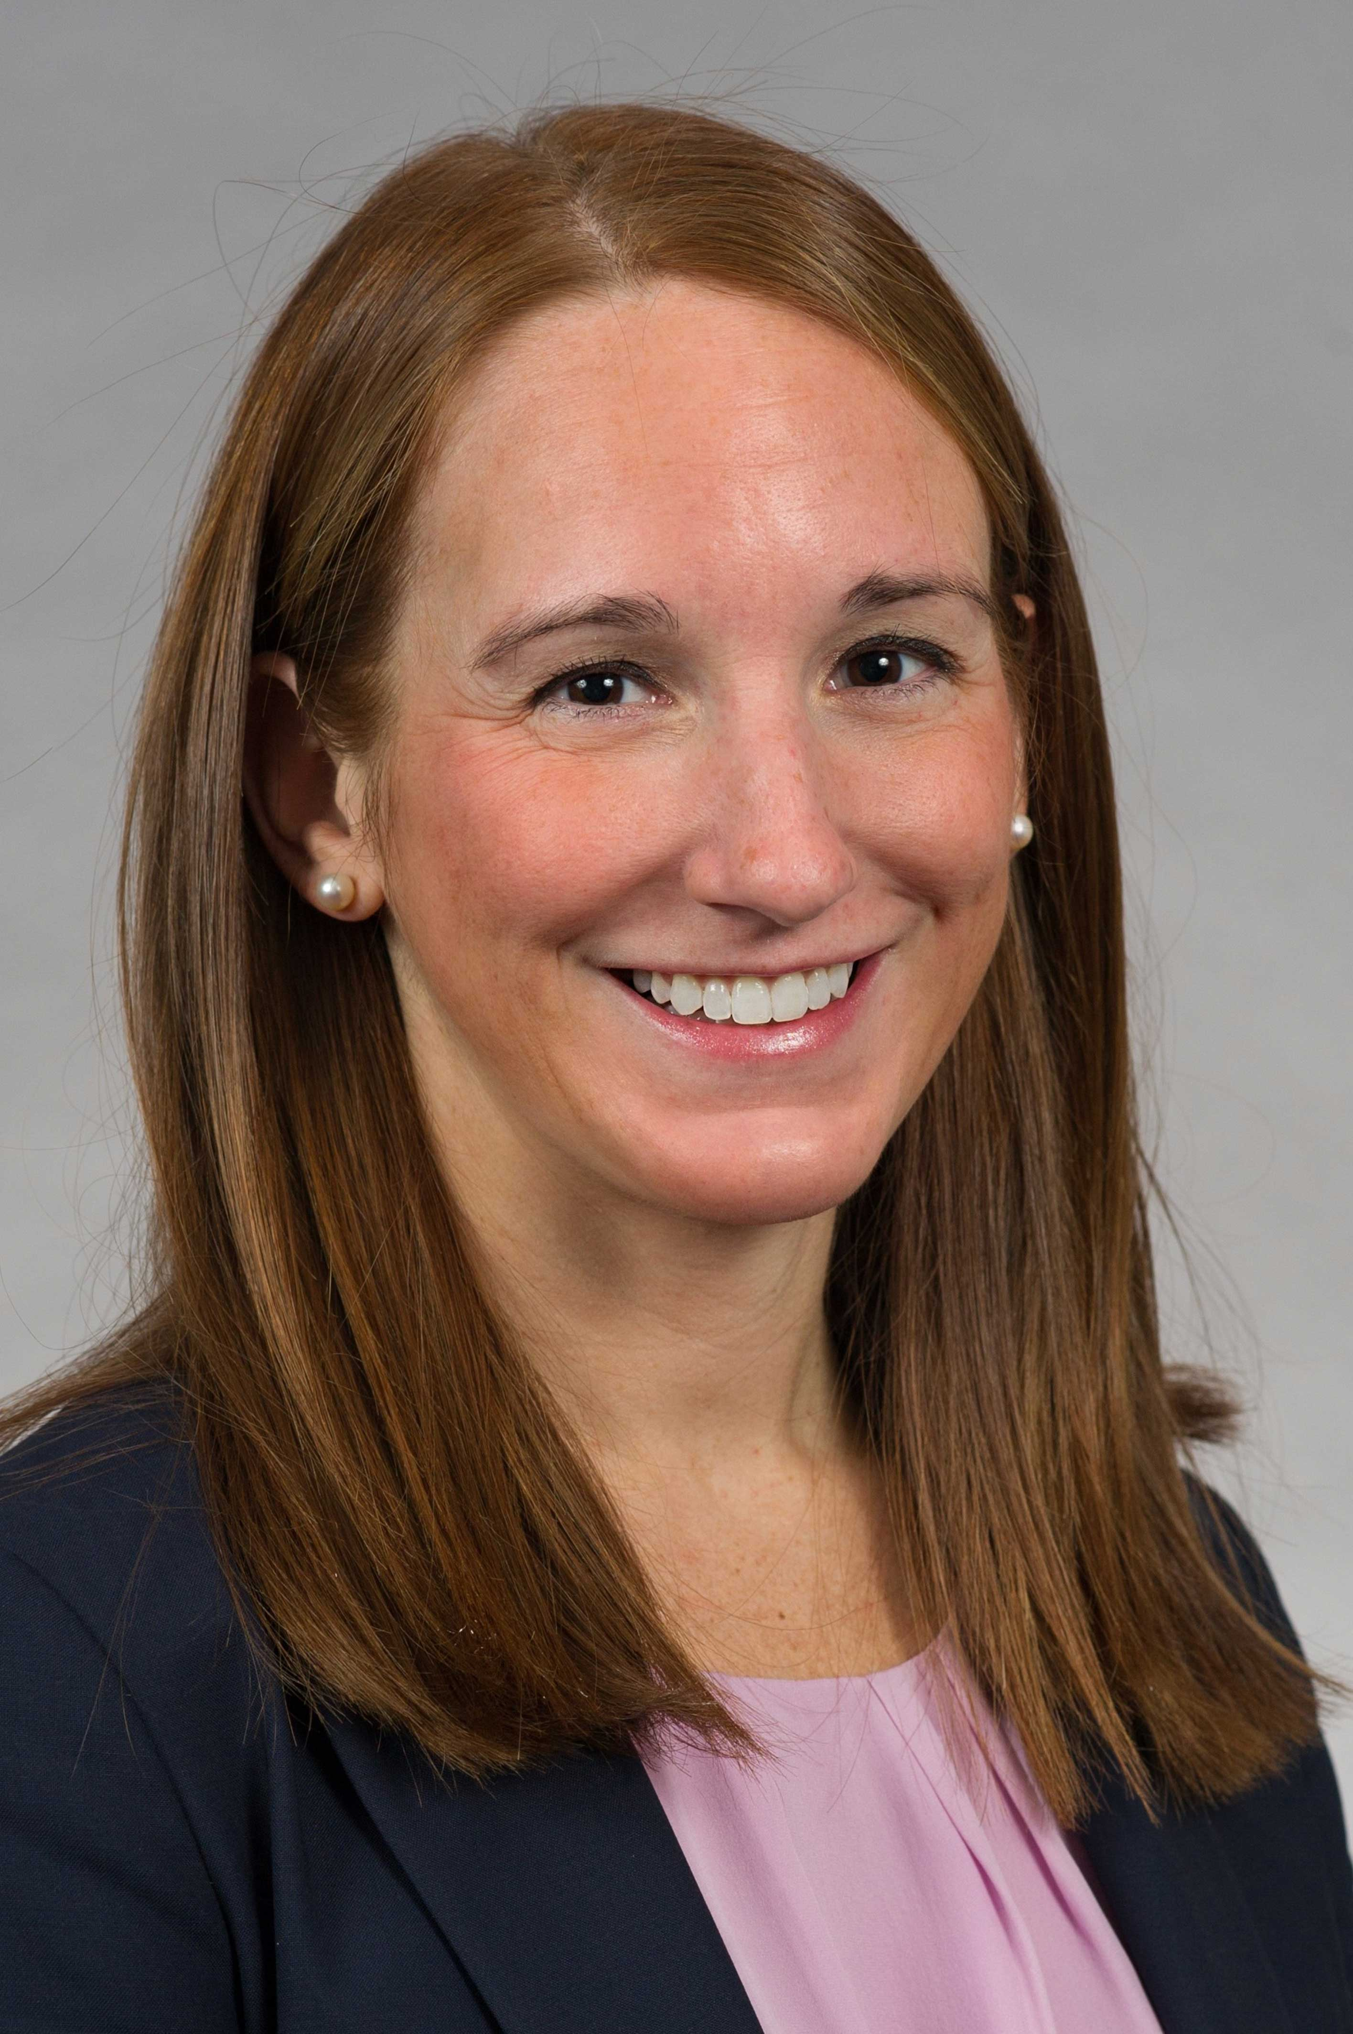
Phone 312.566.4808
Fax 312.566.4810
maz@falkenbergives.com

Practice Areas

Commercial Litigation

Healthcare Litigation

Professional Liability

Megan A. Zmick is an associate at Falkenberg Ives and a member of the firm's commercial litigation, healthcare litigation, and professional liability practices. She focuses her practice on healthcare litigation and arbitration, counseling healthcare clients on compliance issues, and defending lawyers and accountants in professional liability matters.

Ms. Zmick has represented healthcare clients in matters involving member claims, ERISA, Medicare preemption, Medicare fraud, provider disputes, provider fraud detection, breach of contract claims, and bad faith litigation. She also regularly advises healthcare clients on compliance matters involving state and federal laws and regulations.

Ms. Zmick has extensive experience assisting healthcare clients in responding to government information requests from the Centers for Medicare & Medicaid Services (CMS), Office of Inspector General (Department of Health and Human Services), Department of Labor, Federal Bureau of Investigation, Department of Justice, state law enforcement, state departments of insurance, state departments of health and state licensing boards.

In addition, Ms. Zmick has substantial experience representing lawyers and accountants in professional liability matters and commercial disputes.

Ms. Zmick has represented clients in state and federal courts and before various state and federal regulatory agencies. She has experience in all aspects of litigation, including trials, motion practice, depositions, settlement and mediation. Ms. Zmick develops good working relationships with her clients and works closely with her clients to achieve cost-effective solutions to complex legal issues.

Education/Bar Admissions
Ms. Zmick received a B.A. in Business Administration, cum laude, in 2008 from Illinois Wesleyan University, where she was a member of Omicron Delta Epsilon, the International Honor Society for Economics. She received her J.D., cum laude, in 2011 from Loyola University Chicago School of Law, where she was a student articles editor for the Loyola University Chicago Law Journal, a recipient of a CALI Excellence for the Future Award, and served as a student academic tutor in legal writing.
Ms. Zmick was admitted to the Illinois bar in 2011. She is also admitted to practice before the U.S. District Court for the Northern District of Illinois and the United States District Court for the Eastern District of Wisconsin.

Professional Activities
Ms. Zmick is active in various professional organizations, including:
- Chicago Bar Association
- Women’s Bar Association of Illinois
- Illinois State Bar Association

